When Christ was on the earth he build His Church. Paul teaches us in the Epistle to the Ephesians that Christ’s Church was built upon a “foundation of Apostles and Prophets, Jesus Christ himself being the chief cornerstone.”

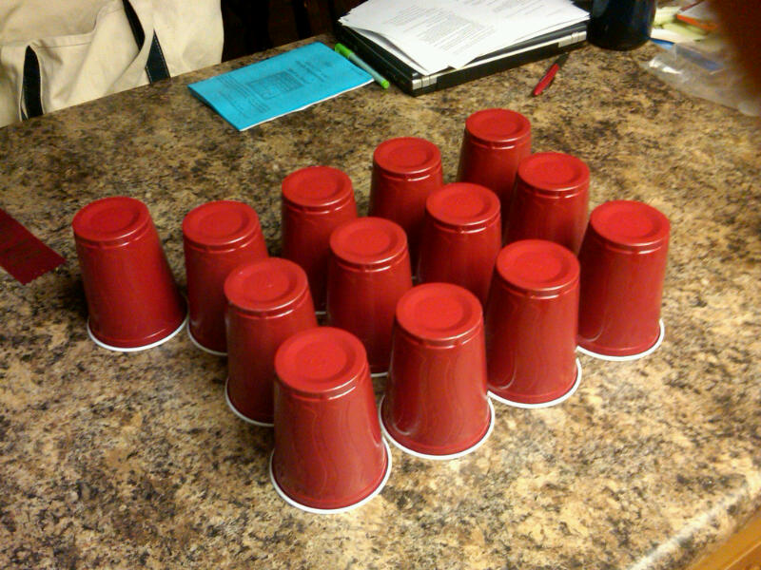

He then called others to help teach the Gospel. Namely Pastors, Teachers, Evangelists, and so forth (Bishops, Stake Presidents, Priests, Teachers, Deacons, Elders Quorum Presidents, Relief Society Presidents)

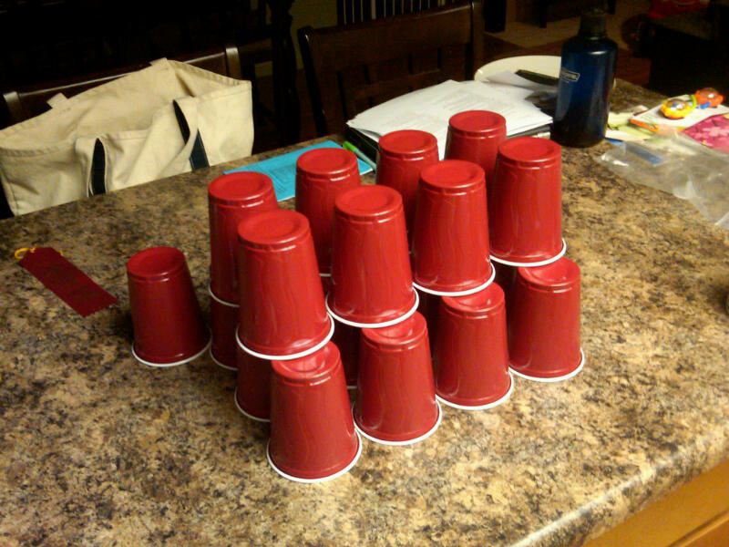

Thos people then helped Christ teach the first principles and ordinances of the Gospel, which are, “Faith, Repentance, Baptism, and the Gift of the Holy Ghost.”

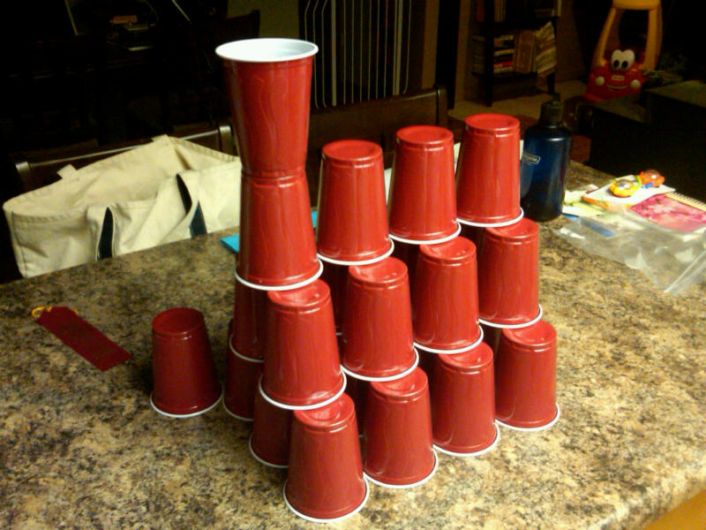

After Christ was crucified his Apostles continued to preach the Gospel, but one by one they were killed for the things that they were teaching.

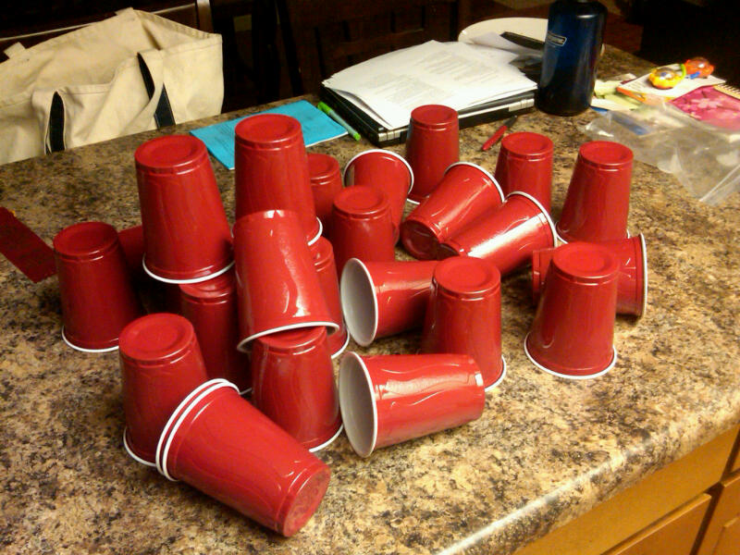

People remembered what Christ had taught and so they began to build Churches with what they remember. Some built churches around faith, others about prayer. Each had great parts of the Gospel, but none of them had the fullness of the Gospel. None of these churches look quite like the one that Christ built.

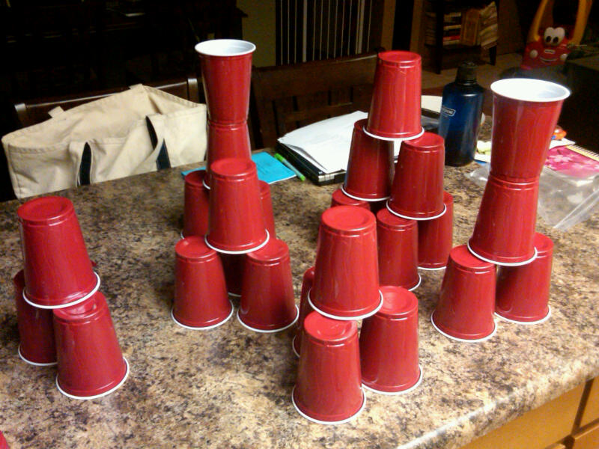

When Joseph Smith was a child he wondered which of all these Churches was the correct one to attend. He read a scripture in the book of James that taught “If any of you lack wisdom, let him ask of God.” He learned that if he prayed, he could obtain an answer. Heavenly Father and Jesus Christ called Joseph Smith to be a Prophet and restore the Church that Jesus Christ has built. He called 12 Apostles.

Once again, others were called to help spread the good news. Pastors, Teachers, Evangelists, and so forth (Bishops, Stake Presidents, Priests, Teachers, Deacons, Elders Quorum Presidents, Relief Society Presidents) all helped teach.

They taught about Faith, Repentance, Baptism, and the Gift of the Holy Ghost. The Church was once again built up just like Christ had built it.

